15. Add a background picture to a web page and write a HTML program for backgroundrepeat using CSS.
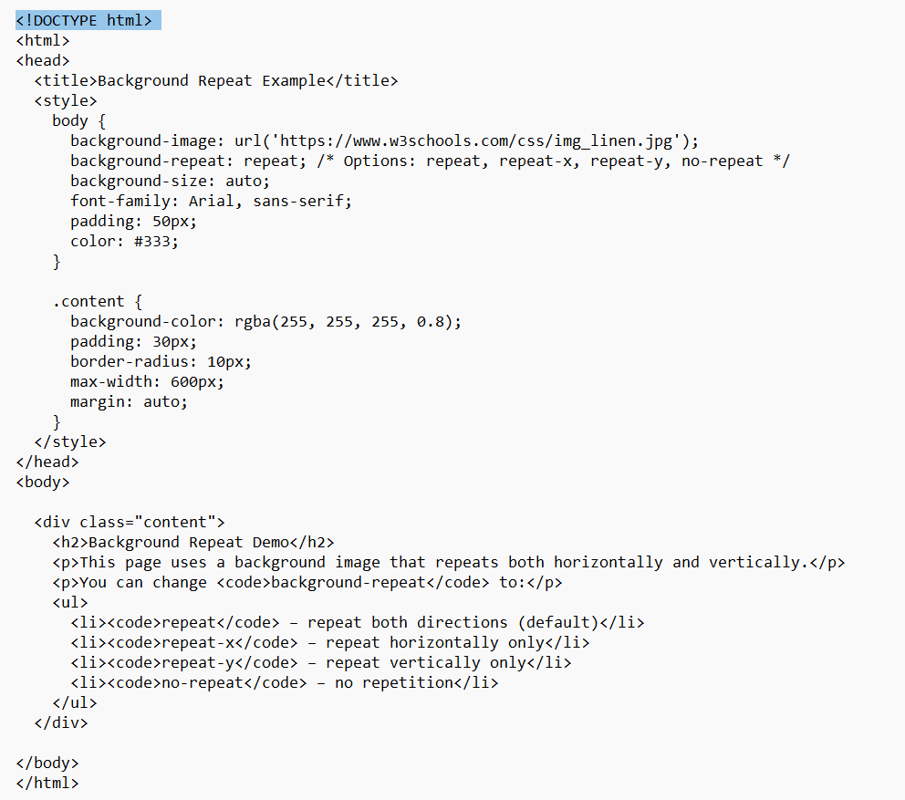
Output
